IT company Structure :

1. System Analysis ( business needs) .
2. Project manager
3. Project coordinator
4. Lead developer (technical)
5. Devops
6. Senior developer
7. QA
8. Developer
9. Contracter

.equal()

1. Web forms
2. URL
3. Cookies
4. Session
5. Get data that send from webform on both method (get,Post) without using Request
6. How data send on post
7. What is the main factors that control post size
8. Can I see the data send on POST method (sniffing tools )
9. Write a PHP script, which changes the color of string. (on the same page)
10. Search engine website, make a form that take website name and when you click on go will redirect you to the website you entered.
11. Make input text that accept youtube video url , when I click on show will be imbedded on the same page.
12. Form builder 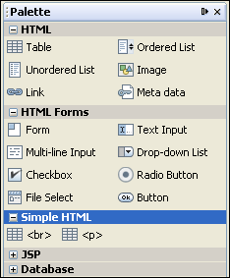

Live server

Staging server

Dev Server

(PC)

Dev Server

(PC)

Testing server

Dev Server

(PC)